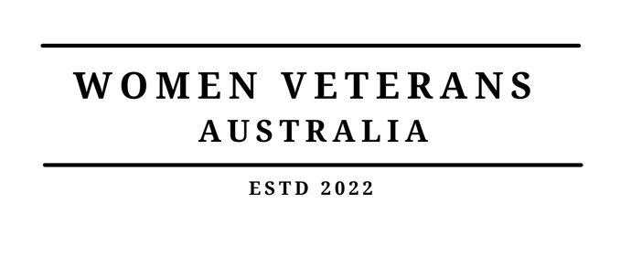

Application for membership to Women Veterans Australia
(WVUA Ltd ACN 649 552 803)

Women Veterans Australia (WVUA Ltd) is Australia’s only not-for-profit charity that provides support and services to help women veterans achieve their full potential. It is an inclusive organisation, regardless of gender identity, sexual identity, age, ethnicity, or any other intersection that compromises women veterans’ quality of life. Women Veterans Australia is determined to provide women veterans with community & connection, referral & resources, and mentoring & development.

Members of Women Veterans Australia (WVUA Ltd) are entitled to vote at the Annual General Meeting (AGM) and Extra ordinary General meetings of the company and are expected to attend such meetings. All Directors must be elected or re-elected annually at the AGM.

Current membership fee is set at $10.00 per annum. Payment can be made to:

WVUA Limited
633-000 (Bendigo Bank)
206060980

Please use your surname as Reference Number.

Applicant’s Surname
Applicants First Name
Address
Telephone
Email

I hereby apply to become a member of Women Veterans Australia and I agree to be bound by the provisions of the WVUA Limited’s Constitution.

Signed: Date:

Please email the completed form to
wva-support@womenveteransaustralia.org.au.

